New York City Internet Health Report

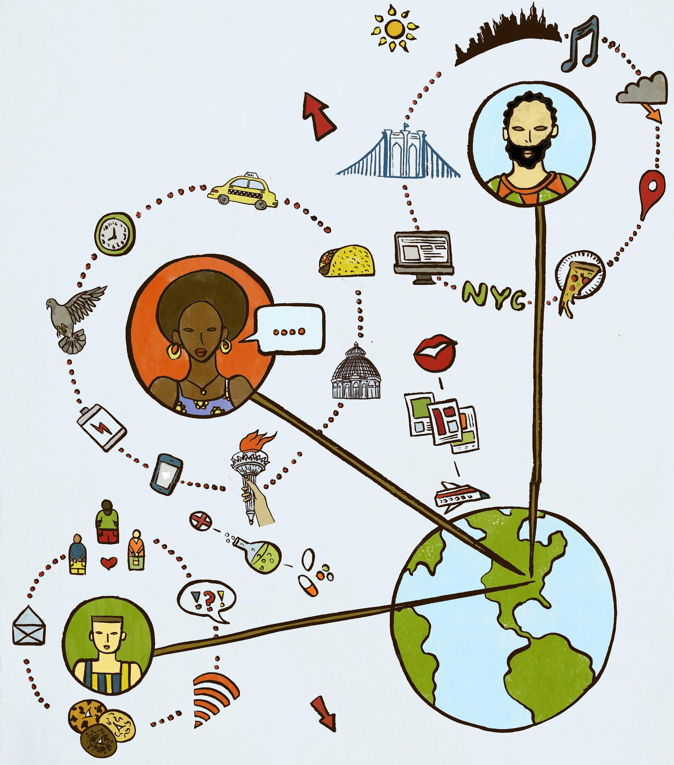

Meghan McDermott, Mozilla Foundation
APRIL, 2019

Illustrations

Grace Lynne Haynes: www.bygracelynne.com

Attributions

Rights and permissions: This work is available under a Creative Commons Attribution 4.0 International license (https://creativecommons.org/licenses/by/4.0), excluding portions of content attributed to third parties. Under this license, you are free to copy, redistribute, and adapt the material under the following terms:
- Attribution: Please cite this work as follows: Mozilla Foundation, New York City Internet Health Report, v.1.0 2019. CC BY 4.0
- Adaptations: If you remix, transform, or build upon this work, please add the following disclaimer along with the attribution: “This is an adaptation of an original work by Mozilla Foundation. Views and opinions expressed in the adaptation are the sole responsibility of the author or authors of the adaptation and are not endorsed by the foundation.”

Topics

- Digital Inclusion: Who is welcome? It’s not just about how many people have
access to the internet, but how that access is safe and meaningful for all of us.

  - Walei Sabry, Mayor’s Office of People with Disabilities
  - Rashida Richardson, AI Now Institute

- Decentralization: Who controls it? A few large players dominate much of the
online world, but the internet is healthier when it is controlled by many.

  - Max Sevillia, Mayor’s Office of the Chief Technology Officer
  - Houman Saberi, New America

- Open: How open is it? The internet is transformative because it is open: everyone
can participate and innovate. But openness is not guaranteed – it’s always under
attack.

  - Adrienne Schmoeker, Mayor’s Office of Data Analytics
  - Noel Hidalgo, BetaNYC

- Digital Privacy & Safety: Is it safe? The internet is where we live, love, learn and communicate freely. To be ourselves, we need to trust systems that protect.

  - Melissa Morrone, Brooklyn Public Library
  - Sarah Aoun, OpSec Specialist

- Web Literacy: Who can succeed? Getting online isn’t enough on its own. Everyone
needs skills to read, write and participate in the digital world.

  - Michael Preston, CSNYC/CSforALL
  - Davis Erin Anderson, METRO

Contents
Illustrations 1
Attributions 1
Topics 2
Introduction 4
Internet Health and NYC 4
Why Now? 4
NYC’s Digital Ecosystem 5
How We Did It 6
What We Heard 6
Looking Forward 7
Digital Inclusion 9
Meet Walei. 12
Meet Rashida. 14
Decentralization 17
Meet Max. 20
Meet Houman. 22
Openness 24
Meet Adrienne. 28
Meet Noel. 30
Digital Privacy & Security 33
Meet Melissa. 35
Meet Sarah. 37
WEB LITERACY 39
Meet Michael. 42
Meet Davis. 45
Participate/Now what? 46
Acknowledgements 47

Introduction

Internet Health and NYC

Welcome to the New York City Internet Health Report, a Mozilla project made possible in collaboration with the NYC Mayor's Office of the Chief Technology Officer. To demonstrate what makes internet health meaningful for stakeholders and communities at the municipal level, this collection of case studies offers a portrait of a vibrant city working in different ways toward a common public good – an inclusive, safe, secure, open, and decentralized internet.

This is the first time the global report has been adapted to a city, and we hope it inspires many more localized efforts to use internet health as a framework for developing strategies to achieve digital equity in our communities. The internet is a dynamic global resource with wide-ranging local impacts, so a report tailored to NYC enables us to examine and champion how people, civil society institutions, government, and advocates – all committed to digital rights – can make our relationship to the internet healthier across five crucial issue areas:

- Digital inclusion: Beyond access, participation is safe and meaningful for all of us, including those who are traditionally marginalized or excluded from digital participation.
- Decentralization: Instead of a few, the internet is controlled by many, for greater resilience, more diversity, and to prevent harmful concentrations of power.
- Privacy and security: Everyone is able to assess and use digital and data systems safely.
- Openness: Technologies and data that drive the Web are transparent and actionable.
- Web literacy: Everyone can read, write, and participate in the digital era, as producers and consumers.

Piloting this project with NYC was intentional. After Mozilla launched the internet health framework in 2017, NYC saw its utility as a framework for action and planning, informed by a shared holistic approach to the internet and Mayor de Blasio’s commitment to values of justice driving the City’s historic tech and data focus. Now, there is evidence to report back on; we have a lot to learn from NYC's leaders about how to build healthy local digital ecosystems. By mapping these issues, and observing how they intersect with life in the city, this report illustrates the changing digital terrain in NYC and how intent, planning, and leadership -- in and out of government -- result in outcomes. Ideally, it helps stakeholders, decisionmakers, and advocates identify best practices that, with City investment, amplify initiatives and policies driven by civil society organizations towards continuous and positive impact — from technology initiatives in the public interest to equity-driven government investments serving all New Yorkers.

Why Now?

This pilot report comes as historic advances in technologies of connectivity change how we connect with the world and each other, making the internet more indispensable and complex than ever. Although shifts open up new opportunities for justice, economic empowerment, and even happiness, they also come with immense emerging risks. Every day, New Yorkers rely on the internet to communicate, learn, work, and play. They also increasingly contend with proprietary algorithms making high-stakes decisions about their lives and families; data being shared and sold without consent; as well as persistent online harassment and increasing disinformation cycles. As a result, we see the erosion of public trust in civic processes that are rapidly moving online: crucial things like voting, the delivery of public services, and the newly digital decennial census.

It’s the right time for NYC to re-imagine its relationship with the internet, to maximize its potential for being a fair and just city, not simply a “smart” one. That’s one reason why NYC has helped to launch the Cities Coalition for Digital Rights with Amsterdam and Barcelona. Together, and with a growing number of cities around the world, they are “committed to eliminating impediments to harnessing technological opportunities that improve the lives of our constituents, and to providing trustworthy and secure digital services and infrastructures that support our communities.” As cities, they “believe that human rights principles such as privacy, freedom of expression, and democracy must be incorporated by design into digital platforms starting with locally-controlled digital infrastructures and services.” As people wake up to the digital landscape, cities have the opportunity to be more accountable to the public they serve, and better define the practice of democracy in a digital era.

NYC’s Digital Ecosystem

The NYC Internet Health report grows from a rich, local tradition of defining, planning, and working to improve NYC’s digital wellbeing. For example, starting in 2011 with the Bloomberg administration, the City of New York released a roadmap to realize its digital potential through 40 initiatives related to infrastructure, education, open data, engagement, and industry. Since then, the scale of the internet’s impact on our daily lives and the increased delivery of city services via digital platforms has increased exponentially. On the civil society side, Civic Hall emerged to support public interest innovations using technology while BetaNYC generated community input into the People’s RoadMap for a Digital New York. In 2016, Tech:NYC launched to foster a creative startup and innovation culture, while Data & Society has spent years producing compelling research at the intersection of technology and society to better inform public debate.

The activities and exemplars featured in this review, however, derive from the willingness of NYC’s CTO’s office to tackle inequalities through a steady shift in principled investment in and guidance

of tech infrastructure, targeted policy-making, and public access initiatives such as LinkNYC and NYC Connected; an Internet Health & Human Rights working group across NYC government agencies; digital privacy workshops in the libraries citywide; and digital safety trainings for immigrant-serving organizations. NYC also boasts a City Council that prioritizes algorithmic accountability and privacy legislation that protects individually identifiable information.

The internet health work featured here also builds from civil society convenings hosted first by the public library systems and then by The New School’s Digital Equity Lab, a research institute at The New School that examines structural inequities that persist and evolve as technology transforms culture, society, and politics. Taken together, and further inspired by public events like the Glassroom, which saw nearly 10,000 people pass through to learn about digital privacy, these efforts lay the groundwork for further conversations, legislation, and policies shaping the quality of life for all residents.

How We Did It

Recognizing the momentum above, and building on the City’s deep bench of knowledge and experience, the NYC Internet Health Report is an experiment in localization to bridge place-based and community-driven projects with the universal goals of the internet health framework.

Over the course of a year, Mozilla Fellow Meghan McDermott and CTO Senior Manager Samantha Grassle, collaborated to curate this field scan of the City’s digital landscape and its digital horizon, with the CTO’s office facilitating connections to a range of different activities, experts, and leaders. Through scoping research, mapping trends, hosting convenings, and Mozilla-supported hands-on activities such as Data Detox trainings, as well as conducting interviews about the state of internet health in NYC and how it can be evolved, we produced this document.

In applying five internet health issues as a new way to surface and categorize digital trends, research, values-driven policies, and essential voices – the often unsung strategies and people making the City’s internet ecosystem healthier – we identified public and private initiatives relevant and urgent to the technological and cultural moment. From building municipal influence through collective procurement power to the advancement of libraries and public computer centers as nodes of community learning and empowerment, there is amazing work to lift up across the City.

And that is intentional – what’s wrong with the internet dominates the conversation. This report is about shining a light on what is possible and what’s working now, with people at the center – healthy, ethical digital cities.

There’s a lot of work to do. Here’s how city government and civil society leaders can continue to be active partners in ensuring a values-driven approach to digital rights and internet health.

What We Heard

As you will see in the pages ahead, there are structural and persistent challenges that New Yorkers encounter every day in relation to the internet, from developing web literacy skills to joining the digital workforce. And there are incredible, passionate people in and out of government who are making change in service to a healthy city and digital ecosystem for all residents. Some strategies they recommend for a healthy internet and a healthy New York include:

Community engagement: Internet health is not possible without the authentic engagement of those who are negatively affected by problematic interactions across markets, governments, and industry. Ensuring pathways for people and communities to steward and shape the technology that will build equal opportunity and justice is essential. What does that look like?

- A digital workforce development ecosystem informed by communities in need, from local digital stewards helping their neighbors get online and use the internet to opportunities that open doors for all, not just those who start out ahead in terms of digital access and resources;
- Meaningful public demand for open data to hold government to account; direct review of automated decision systems and recommended actions for redress of harm;
- The development of a city-wide digital equity alliance to ensure community voice in redefining “smart” as ethical and responsible to residents, including adoption of community-shaped principles for data and privacy.

Investment: Technology moves quickly, but gaps and challenges in physical infrastructure ground and limit the benefit of technological advancement over time and in places that are historically under-resourced. To make investments matter for equity, consider:

- High-speed, affordable broadband for everyone;
- Increased public awareness of, and engagement in, oversight of smart city frameworks for government and private sector projects and to manage the challenges of digitally connected infrastructure, from data management and ownership to privacy and security standards;
- Tools built through open frameworks and open source, specially through accountable and transparent processes applying best-practices standards for openness and privacy;
- Support for essential digital skills to be available and embraced, from web literacy and Data Detox trainings to incentives for improving the cyber security of community organizations;

- A City bond to tie CS roll-out to schools with broadband updates and device distribution.

Oversight: A healthy city provides accountability for its tech investment and engagement strategies. Here’s what NYC’s municipal government can do with support from civil society partners:

- Informed by city government practices and increased community input, pilot a framework for assessing the impacts of automated decision systems targeting use cases in criminal justice, child welfare, and education;
- The use of purchasing power to push industry to do better on accessibility and privacy;
- Enforceable, ethical standards on retention and usage for vendors to keep data safe, with more accountability when it comes to data privacy overall.

Looking Forward

The line between life online and off is disappearing. From connected devices to smart homes, the internet is everywhere, further blurring public and private spaces. For cities in particular, density, scale, and need magnify the challenges, and the opportunities, to improve the internet itself, our relationship to it, and how it affects our communities. Let’s take the lessons learned here and organize conditions for a better next, and like Houman Saberi shares, “build an infrastructure of hope.”

Digital Inclusion
Who is welcome? It’s not just about how many people have access to the internet, but how that access is safe and meaningful for all of us.

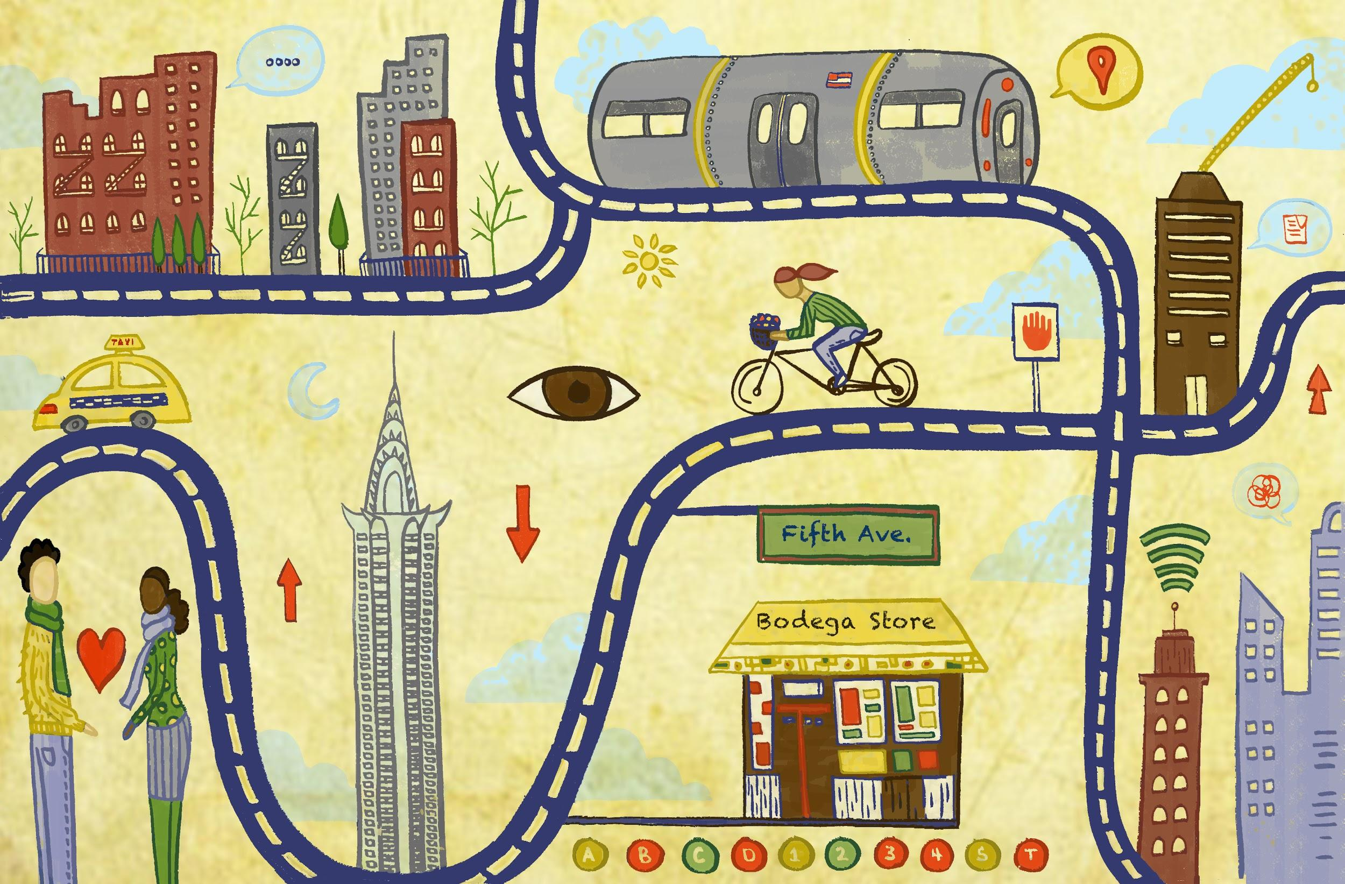
The flow of people across the city - on bikes, in taxis, on subways - parallels its diverse movement of information and data with different modes of access and communication for everyone.

We know the internet can open doors for many, but without the appropriate policies and programs in place, it can also leave others behind. There are many initiatives inside city government and within NYC communities dedicated to improving how New Yorkers use the internet, and how they are impacted by it.

Queensbridge Connected is a community-wide network WiFi model implemented at Queensbridge Houses in Long Island City, Queens, the largest public housing development in the Western Hemisphere. This award-winning program provides free-high speed WiFi and WiFi calling access with speeds up to 25 Mbps and seamless connectivity throughout the development. With a specific

focus on inclusion, the project hires and trains residents from the Queensbridge houses to build, support, and promote the network, while also offering device-loaning and free computer classes that focus on building digital skills and online safety awareness.

The Mayor’s Office of People with Disabilities (MOPD) works to make NYC the most accessible city in the world, and this includes making all of the City of New York’s websites fully accessible to people with disabilities. Mandated by local legislation, the agency releases biannual reports on the state of accessibility of NYC websites. In July 2017, 71% of websites were deemed accessible, and the office is working to significantly improve those numbers with new policies and agency training materials.

Just this year, MOPD also launched the AbiliTy Cisco Academy in partnership with UJA-Federation of New York, J.E.&Z.B.Butler Foundation, BNPParibas, and Standard Chartered Bank. This program builds on a “train-to-place” model to connect people with disabilities in New York with an industry- leading cybersecurity program and then place them in critically needed cybersecurity positions.

Launched by Mayor de Blasio in 2014, the NYC Tech Talent Pipeline is the City’s tech Industry Partnership, designed to support the inclusive growth of the NYC tech sector and prepare New Yorkers for 21st century jobs. Incubated and supported by the NYC Department of Small Business Services, the NYC Tech Talent Pipeline works with 275+ companies, 17 local colleges, and additional public and private partners to define employer needs, develop training, education, and recruitment models to meet these needs, and scale solutions throughout the City—delivering quality talent for the City’s businesses and quality jobs for New Yorkers.

There are many NYC-based community programs that are working hard to build an inclusive internet ecosystem. To name a few:

- Girls Who Code is a nonprofit working to close the gender gap in the technology sector. Founded in NYC by Reshma Saujani, the organization has reached over 90,000 girls of all backgrounds in all 50 states.
- Black Girls Code is a NYC-based nonprofit working to increase the number of women of color working in technology, with a goal to train 1 million girls by 2020.
- Pursuit (formerly Coalition for Queens) is a nonprofit organization based in Queens with a mission to train adults in need to get their first tech jobs, advance in their careers and become tech leaders for the next generation.
- Older Adults Technology Services (OATS) is a NYC-based nonprofit dedicated to helping senior citizens utilize technology to live successful, independent, and more connected lives. The organization supports critical community programs like Queensbridge Connected.
- Lesbians Who Tech is a nonprofit in NYC that Queer women working in or around technology. To date, the group supports over 40,000 non-binary people, women, people of color, and LGBTQ technology professionals with annual summits and scholarship opportunities.

A big emerging issue in digital inclusion involves how new automated technologies might perpetuate new forms of discrimination and exclusion. Because of this, it’s important for cities to examine how algorithms are used to make decisions. The City of New York last year convened the first taskforce in the nation for reviewing “automated decision systems” – more commonly known as algorithms – through the lens of equity, fairness, and accountability. The taskforce will produce a report in late 2019 recommending procedures for reviewing and assessing City algorithmic tools.

Meet Walei.
“accessibility is a selling point, not just another check box for compliance”

Walei Sabry is NYC’s first Digital Accessibility Coordinator. Sitting between the Mayor’s Office of People with Disabilities (MoPD) and the Department of Information Technology & Telecommunications (DoITT), his unique position is to ensure that all NYC residents, especially those with different abilities, can access city services offered over the internet. A long-time advocate for people with disabilities, Walei knows first-hand what the barriers are. Drawing from lived experience and his technical expertise, he now trains and supports more than 50 city agencies to provide better digital accessibility for over 300 websites and 50,000 pages, reaching more than one million New Yorkers living with disabilities.

Mozilla Foundation (MF): Tell us about your work.
Walei: As Digital Accessibility Coordinator, I am responsible for making the City’s digital products work well for people with disabilities. Many tools and sites that are important to digital safety are not accessible. There is an incredible amount of work to do in this space, starting with engaging companies and organizations to make improvements. For example, the City of New York uses many digital technologies including websites, electronic documents, social media, videos, and apps, and my job is to ensure that everyone can use them. I’ve also instituted a series of free, public cybersecurity trainings and Data Detoxes specifically designed for people with disabilities.

MF: What are you proud of?
Walei: In 2015, I was working with MoPD when NYC’s Department of Education announced that Amazon had won its bid to create a new e-book marketplace for the City’s 1,800 public schools. At the time, Amazon’s accessibility standards were less than satisfactory, and did not seem to be a top priority for the corporation. The National Federation of the Blind had been battling with Amazon over accessibility standards for years, and in this case, they had sent several letters and planned protests to draw attention to the thousands of NYC public school students and teachers with disabilities who would be left behind by this $30 million contract.

From the city-side, I spoke from a personal point of view and was at the table to arbitrate for tangible accessibility goals moving forward. Since then, Amazon has come full circle – they promote an accessibility culture within Amazon that has led to many new features and devices. They’ve built their own screen reader into Kindle devices and audio description into Amazon prime, for example. Now, accessibility is a selling point, not just another check box for compliance. In the end, the National Federation for the Blind and Amazon announced a joint commitment to work together to improve accessible reading experiences for blind and low-vision students.

More recently, I started a digital inclusion committee for city agencies to identify digital accessibility issues and learn together. We’re focusing on making maps more accessible as they are increasingly part of online experiences.

MF: What challenges persist to full accessibility and digital inclusion – locally and beyond?
Walei: NYC has Local Law 26 requires its agencies to undertake reasonable efforts to make websites accessible, and every other year I issue progress reports. Still, more can be done to improve accessibility. For example, unemployment for people with disabilities between the ages of 18 and 65 is 80% across the City. The hope has always been that technology will empower more people with disabilities to enter into the workforce and live more independently. When it comes to City employment, we can and should improve our internal digital accessibility accommodations to ensure more people with disabilities are hired.

One step we’re already taking to change workforce opportunities for people with disabilities overall is NYC@Work initiative. This is a partnership with the private sector, nonprofits, and city agencies to build a talent pool of people with disabilities trained to work in the cybersecurity sector, for example. Globally, everybody should make reasonable accommodations to do the same.

MF: How can NYC be an active partner in this work?
Walei: Maintaining a strong advocacy and awareness mechanism within City government is crucial to pushing better accessibility and digital inclusion ahead. Considering what was possible with Amazon, the City should use its purchasing power and weight to push industry to do better on accessibility. My goal for NYC is to introduce accessibility into everything we encounter. A small example would be making sure that all citywide emails to employees have alt text in images.

Final Word
Walei: In NYC, some City agencies have really started to adopt the language of internet health to improve digital experiences inside City government and for New Yorkers broadly. Looking ahead, I’m thinking about smart cities a lot. These initiatives can go really well or really wrong depending on who’s at the table – people with disabilities must be involved at all stages of the process. NYC can be an active partner by modeling what it takes to engage people with disabilities in everything that affects us, because what works for us makes products better for everyone.

Meet Rashida.
“under the guise of solving inequality, ADS exacerbates harm of those seeking government services”

Rashida Richardson is Director of Policy Research at the AI Now Institute, where she leads research strategy and initiatives on the topics of law, policy, and civil rights. By examining complex social issues at their roots, Rashida works to better deconstruct the values and biases embedded in our rapidly advancing technologies, elevating the potential for more transparent policies and equitable conversations. From the use of questionable data in predictive policing to the discriminatory outcomes enabled by black-box automated decision systems (ADS), Rashida surfaces the injustices baked into tool designs and offers ways for cities and civil society to measure, account for, and transform them. This includes leading advocacy efforts related to the Automated Decision Systems Task Force in NYC. The first of its kind in the US, and reflective of NYC’s strong human rights law, the taskforce will recommend strategies for greater visibility into the City’s use of technology and strategies for redress when harm is done.

MF: Tell us about your work.
Rashida: I am a lawyer and researcher with the AINow Institute at New York University, where we examine the social implications of artificial intelligence and other emerging technologies. This includes facial recognition, teacher evaluation algorithms, and the kinds of risk assessment tools used in criminal justice decisions. I think about how to use the law to address or mitigate the problems we see with AI – for example, to create more transparency and oversight of procurement and use of automated decision systems in NYC.

Last year, we developed the Algorithmic Impact Assessment framework (AIA) to do just that, helping affected communities assess the use of AI for fairness or safety. We also developed a toolkit that breaks down AI and machine-learning concepts, so advocates can understand how algorithms are being used in government to inform their strategies and tactics. By drawing on a long history of legal impact assessments in the human rights, environmental justice, and privacy realms, we build capacity amongst stakeholders, from municipalities to technical experts to the legal community.

Much of our research is on the technology of predictive policing. We looked at counties and cities with long histories of unlawful and biased conduct, and the influence this has on data-driven systems, complicating the predictions they make. Often companies think that by removing specific “bad data” from predictive policing systems they’ll be left with data that won’t produce biases. But all data points are influenced by historical police practices and social inequities, such as race-based housing discrimination, for example. These data sources are inextricably linked – cutting and pasting data doesn't change the bias.

To assess what the problem is and to devise actionable solutions, you have to understand how government works as well as what the interests are of many different stakeholders. So our AIA is, at best, a diagnostic tool for identifying the underlying problems.

MF: What are you proud of?
Rashida: Last year, with a lot of other local organizations, we produced a joint public letter offering recommendations to the NYC taskforce examining government use of ADS. That process, though long, was useful because it forced us to think proactively about solutions rather than simply critiquing the situation. It took many drafts of everything from language and legal phrasing to developing a basic understanding of how some of these systems work in real life. ADS increasingly determine things like public school assignments, Medicaid benefits, and child welfare outcomes. ADS is used in pretrial risk assessment as an actuarial tool for judges deciding if someone should receive bail or not. In each of these cases, the outcome can be grave – a lot is at stake.

It is important to know how decisions are made and to ask, “if the outcomes of an ADS affects different communities differently, then what laws or policies should be used to address those disparate outcomes?” No one person has the answer. So this collaborative effort was a great example of showing why this work has to be interdisciplinary. That’s where change can happen.

MF: What challenges persist to an equitable internet – locally and beyond?
Rashida: AI is forcing larger conversations about structural and systemic biases and harms, both within society and government that, collectively, we’ve been avoiding – especially those with vested interests. The ethics debate in AI is a game of hot potato. Some think it’s up to government to regulate; others think it’s up to the tech sector to figure out. But really we need people from all sectors to both be accountable and feel that it is within their agency to do something.

Another challenge is that massive amounts of data are being collected on vulnerable populations. ADS disproportionately affects lower income communities because they are more likely to access government services, and information-sharing across agencies means it can be harmful. If you received mental health therapy through a government portal, that’s a data point that could be used against you in criminal justice, child services, or education decisions later. If you are someone with means and you go to a private provider, that data doesn’t enter the system. Under the guise of solving inequality, these systems actually exacerbate harm of the very people who seek out government support and services they are entitled to.

MF: How can NYC be an active partner in this work?
Rashida: Pilot the AIA framework! If not citywide initially, then targeting some of the most concerning use cases in criminal justice, child welfare, and education. What would it take to do that? First, define which “automated decision systems” are open to public debate. This step is critical because these systems have huge legal carve-outs and exceptions. Second, use common language to define what

“disparate impact” means to someone who is not a lawyer. Provide ways for the public to raise legal concerns and provide feedback, and for government to actually respond. Funding to do that, and community engagement, will determine the AIA framework’s value overall. Lastly, consider a private right of action – that means the right to sue for harm caused by a decision or practice – to hold agencies accountable.

Final Word
Rashida: AI tends to scare people. But it’s actually people and communities affected by these technologies and government decisions who have greater insight into the social inequalities that these same technologies can scale and worsen. Everyone has something to contribute to this conversation. Everyone should have a seat at the digital table.

Decentralization
Who controls it? A few large players dominate much of the online world, but the internet is healthier when it is controlled by many.

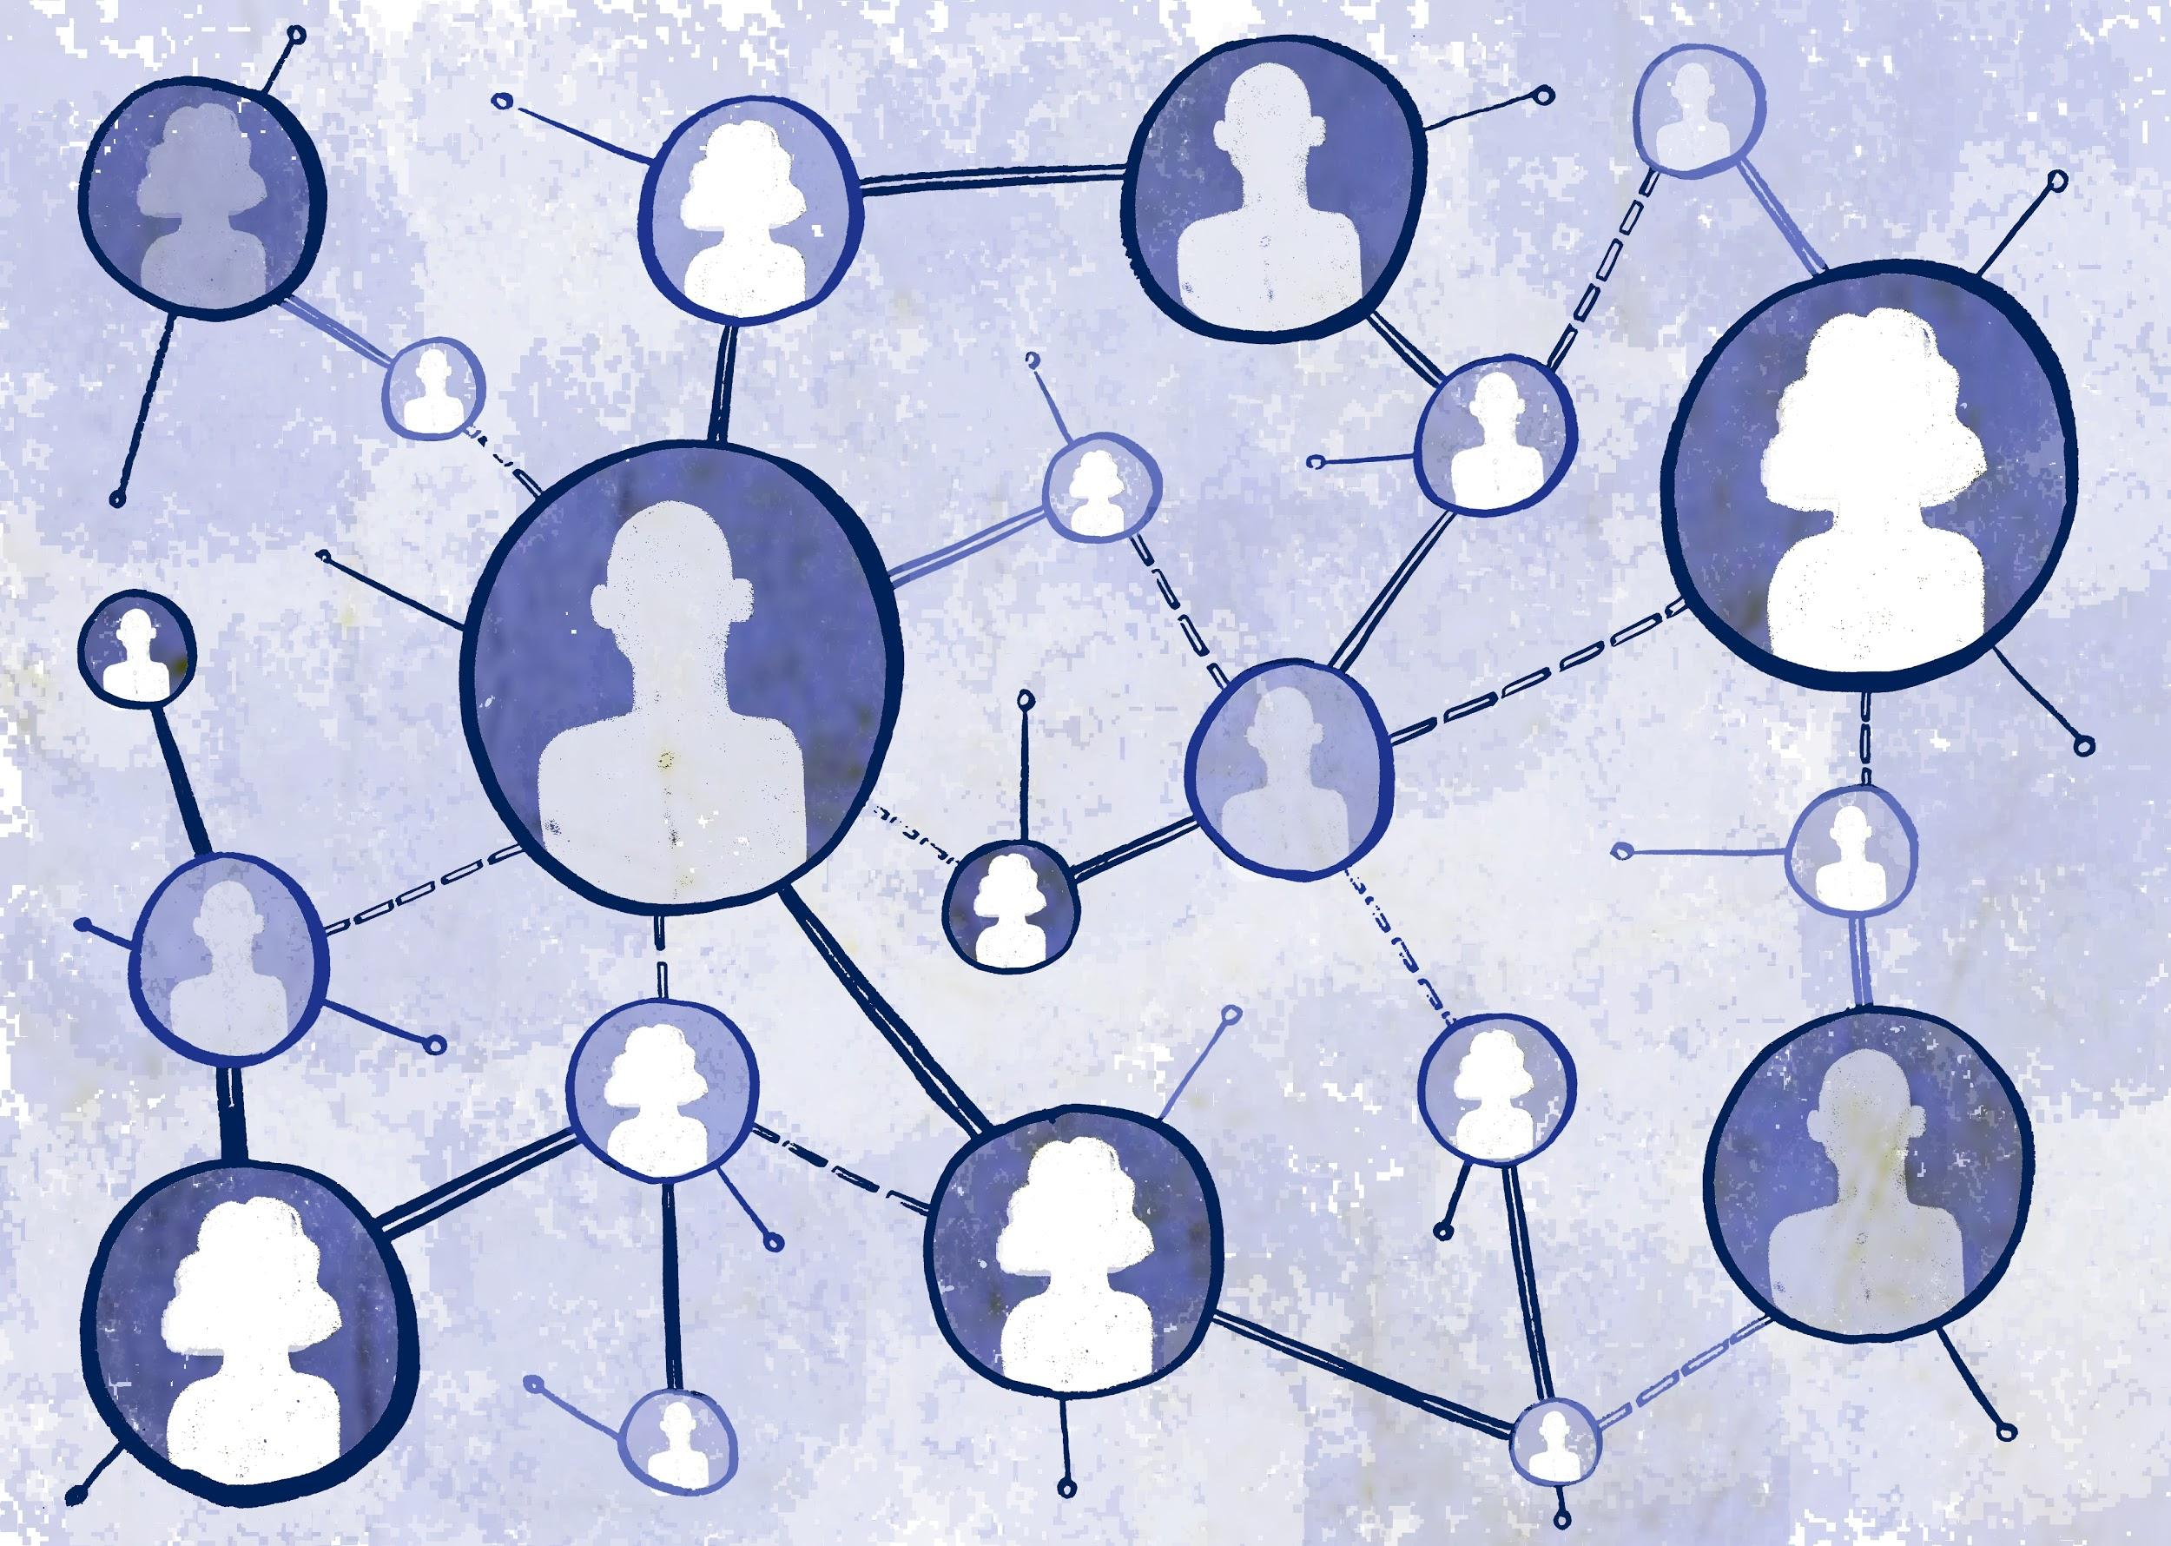
Many nodes are linked across the page to illustrate broad ownership of infrastructure and an expanded ability to access the internet equally.

An important topic for the City of New York involves the issue of decentralization and how it impacts New Yorkers as they access the internet through their local internet service provider (ISP). The Mayor’s Office of the CTO is tasked with achieving the Mayor’s OneNYC goal that all New Yorkers have access to high-speed, affordable internet. In 2018, the City released “Truth in Broadband: Access and Connectivity in New York City,” a first-of-its-kind report to understand the state of broadband in NYC, drawing from national data and measuring the current state in terms of equity, performance, affordability, privacy, and choice. The choice section directly lays out the

state of decentralization and internet access. Notably, the report finds that “more than two thirds of households (69%) and nearly three quarters of small businesses (72%) have only one or two options of broadband providers.” This lack of choice has tremendous implications for New Yorkers, driving up prices and resulting in inequitable coverage and poor service.

To address this, the Mayor’s Office of the CTO has made choice a priority in their universal broadband planning effort, stating that “at a minimum, every household and business should have three options for broadband service to avoid a duopoly and ensure no area of the city faces a monopoly.”

There are also several important local efforts to increase and improve internet service options on a community level.

- Located in south Brooklyn, Red Hook Initiative is a comprehensive youth development and community-building organization that broke ground defining community-owned WiFi in NYC with its Digital Stewards initiative. “Creating Change from Within,” RHI runs a paid, 8-month training for young people to learn how to maintain and promote the Red Hook WiFi network, a free wireless network that RHI built to fortify local resiliency and span the digital divide. With the long-term goal of providing Red Hook NYCHA residents with free WiFi, RHI kicked off its connectivity effort by providing 38 business partners on commercial corridors with Red Hook WiFi. In 2018 Red Hook WiFi was accessed over 8,500 times, demonstrating the power of local set-up and local control.

- Following the devastation of Hurricane Sandy, in 2014, the New York Economic Development Corporation issued the RISE:NYC competition to fund resiliency technology projects to better prepare small businesses for destructive natural disasters. One of the selected winners included the Resilient Communities from the New America Foundation, an initiative to create a locally controlled WiFi network that is supported by community members through their Digital Stewards program, which pays community members to maintain the network. These resilient networks are designed to ensure that small businesses still have access to critical communications networks in the wake of future natural disasters should the large internet service providers go out of service again.

- Silicon Harlem is a social venture transforming Harlem into a technology and innovation hub, from co-working spaces and gigabit infrastructure (high-speed connectivity) to securing investment capital and hosting monthly meetups. By growing a local tech ecosystem, Silicon Harlem advocates for all citizens to participate in the digital economy. In this way, decentralization is about knowledge, access, and design: Silicon Harlem is the first company to establish “Community as a Platform” (CaaP), which means community is involved in the planning and deployment of technology throughout the process.

They also launched Gigabit Harlem with broadband providers. To date, over 10 locations now use fiber infrastructure to provide ultraspeed options to business and residents.

- NYC Mesh is another local effort that creates a volunteer-run network bypassing traditional cable operators, helping New Yorkers get cheaper, faster, and more secure internet access. This project uses high-­bandwidth sector antennas, internet exchange points, mesh protocols, and solar batteries to create a decentralized network.

Finally, net neutrality was a big decentralization policy topic for the City of New York in 2018. In the wake of the federal repeal of net neutrality protections, the City led a coalition of cities across the country to commit to not purchase internet service from any provider that violates net neutrality. While the legal future of net neutrality is still to be determined, the City was able to combine forces with a distributed group of cities to leverage collective power against a federal policy that would hurt New Yorkers.

Meet Max.
“equal, unthrottled access to the internet is critical for a level playing field"

Max Sevilia is the Director of External Affairs for the NYC Mayor’s Office of the Chief Technology Officer. An experienced advocate for civil rights, Max builds coalitions and runs campaigns with other cities to advance and protect digital rights for all. Last year, Max led over 200 US cities fighting for policies that expand access to and adoption of a free, open internet. By championing an open internet and equal access for its residents, Max stems the tide of attacks by powerful forces on people's digital rights and freedoms.

MF: Tell us about your work.
Max: In my role as the Director of External Affairs, I represent NYC at the national level on issues related to technology and telecommunications. I also build coalitions between like-minded cities interested in collaborating around specific issues, such as net neutrality and digital rights.

In 2014, I joined Mayor de Blasio as Director of the Federal Legislative Affairs Office, and internet policy was already a major policy priority for NYC. But in 2016, it took on a whole new meaning when FCC Chairman Pai began his tenure by undoing the critical modernization of the Lifeline program. This was an important national subsidy that enabled low-income communities to access broadband services. About half of NYC residents were eligible for this program at that time and NYC successfully advocated for it to be expanded.

Then, when the Trump administration swiftly moved to overturn net neutrality protections in 2017, NYC was positioned to act fast and show leadership. Our first step was partnering with colleagues across city government to communicate that this was bigger than a “tech issue” – it affects all areas of life, including the ability to apply for jobs, enroll in city services, or even just do homework. City residents need access to the internet for critical information related to job opportunities, for education, to stay connected to friends and family, and to start new businesses, among many other reasons. Equal, unthrottled access to the internet is critical for a level playing field.

As we considered how to best respond to this alarming policy change, we saw our purchasing power as significant leverage to hold technology companies to account, and to do the right thing by continuing to follow net neutrality protections. We understood that a national municipal commitment to contract only with Internet Service Providers respecting net neutrality – an open and free internet – could drive national policy, and counter ill-advised decisions from Washington, DC. In NYC alone we spend over $600 million annually to provide internet service to city employees and to offer city services. So, we convened an ad hoc coalition, starting with eight cities committed to only purchasing from broadband providers that honor net neutrality principles. Now, this coalition is over 130 cities.

By partnering with the Free Press Foundation and a broad coalition of NGOs, we built a grassroots movement that engaged everyday residents to write to their mayors to encourage them to join the coalition. Over 80,000 letters were sent, and the coalition grew to over 200 cities in 41 states representing more than 25 million people.

MF: What are you proud of?
Max: I am really proud to be part of a team that recognizes that internet access, adoption, and new technologies will determine the future. Together, we are leading the fight for better policies to make sure that New Yorkers, and all Americans, reach their full potential.

MF: What challenges persist to a decentralized internet – locally and beyond?
Max: We are fighting multiple battles to protect the internet, including the above-mentioned priority to keep it free and open. Our efforts now extend to protecting digital privacy and local authority when it comes to legislating over cutting-edge technologies like smart cities and 5G technology. NYC has focuses on these issues through the Mayor’s Office of the Chief Technology Officer. However, this role is still fairly uncommon in many cities throughout the world. There needs to be a lot of coordination between cities globally to advocate for their role in protecting digital rights.

MF: How can NYC be an active partner in this work?
Max: Universal access is the foundation for ensuring digital equity, therefore we have to invest time and resources towards ensuring that all people have access to high-speed, affordable broadband. We will also continue to lead on other important technology issues, and partner with aligned cities and organizations. For example, in NYC, we have a thriving small business community. Removing net neutrality hurts startups and other economic ventures because it is critical to allowing small businesses entrance into the internet marketplace, giving them a fair chance to reach potential customers.

Final Word
Max: One-size-fits-all policies dictated from Washington on behalf of powerful corporations weaken citizen rights and endanger the experimentation, innovation, and economic development that happens at the local level. When it comes to deploying new technologies, cities are best positioned to determine how to equitably distribute and govern. Recently, we joined the cities of Amsterdam and Barcelona to form the Cities Coalition for Digital Rights, an international coalition of cities focused on advancing and defending their residents’ human rights when they go online. We’re excited about this new initiative that comprehensively and globally extends NYC’s leadership for a fair and equitable digital world. We must remain committed to driving policies that create opportunity for all and that move us all forward.

Meet Houman.
“with decentralized community-led networks, we build an infrastructure of hope”

Houman Saberi is deputy director of the Resilient Communities Initiative. Working in partnership with anchor organizations in five storm-vulnerable neighborhoods in NYC’s flood plains, Houman supports the local creation of community wireless networks. To date, 30 local residents in partner neighborhoods have been trained as Digital Stewards to build and maintain WiFi networks designed to prepare communities for future storms, floods, and stresses. With portable access points, battery packs, and locally hosted applications, these decentralized networks demonstrate an adaptable approach to infrastructure and bring storm-hardened broadband connections to 60 small businesses and their neighbors. They also provide a learning platform for residents to install and maintain local information hubs. Resilient communications networks are crucial before, during, and after a disaster for people to have access to information that can save lives and livelihoods.

MF: Tell us about your work.
Houman: In 2012, Superstorm Sandy exposed the weaknesses of NYC’s infrastructure, as power, transport, and telecommunications systems failed millions of residents across the city. In the Far Rockaways, up to 50% of residents were without power three weeks after the storm. In Sheepshead Bay, Brooklyn, 15,000 people registered for FEMA assistance after the storm. In Red Hook, Brooklyn, where cell phone and internet service were disrupted for weeks, a community WiFi network became the nexus for communication and relief efforts. Local anchor organization the Red Hook Initiative had used the Detroit Community Technology Project’s Digital Stewards program as a model to start its own small WiFi pilot project in the months before Sandy, but after, the network proved crucial to the neighborhood’s storm response, and proof of concept for what we do in NYC.

In 2016, New America’s Resilient Communities Initiative was awarded funding from the City’s Economic Development Corporation (EDC) to build resilient networks for preparedness, recovery, and local small-business development. Through our Digital Stewardship program, developed with the Allied Media Projects in Detroit, and using Portable Network Kits (battery-powered, meshable local server/hotspot kits), we train local organizations how to build resilient WiFi networks that are entirely owned and operated by the community.

How it works: in each partner neighborhood, a community anchor organization trains six to eight local residents as “Digital Stewards” who learn both the hardware and software of WiFi networking, like installing antennas and routers on the rooftops of small businesses in their community. They also learn community-organizing skills that draw from Detroit Digital Justice Principles: emphasizing access, participation, common ownership, and healthy communities.

Beyond technology, we empower people to use their WiFi networking knowledge to facilitate human relationships. Each community organization holds events and spreads awareness to encourage local use and adoption of its network. We work with partners to envision how these networks can strengthen neighborhoods and solve local problems, beyond simply gaining access to the internet. Each is a physical hub for people to connect and build relationships based on trust. Ultimately, we view resiliency as a community-led process of transformation – much more than returning to a previous condition after a natural or man-made disaster. Our environmental and digital futures are interlinked; with decentralized, flexible, and adaptable community-led networks we build an infrastructure of hope. The internet is healthy when the physical infrastructure is decentralized to support the knowledge and control that local residents need to build their own.

MF: What are you proud of?
Houman :Three neighborhoods have started the installation process and two networks are almost complete! This comes after two and a half years spent on partnership development, training, community outreach, network designs, and bureaucratic delays. Moving from an abstract concept to concrete installation is incredibly fulfilling. I’m proud of our team, our community partners, the Digital Stewards, and small businesses participating in this project. Eventually, people will see how this process of building community networks has shifted their relationship to the internet from being passive consumers to being producers of it. In other words, don’t wait for the internet – build it.

MF: What challenges persist to a decentralized internet – locally and beyond?
Houman: Right now, everything about the internet makes us passive consumers. We’ve lost agency. We have to reconceive what’s possible – for the future of the web and our resilient communities. Trust takes time, and decentralization, given its bespoke nature, makes it all take longer.

MF: How can NYC be an active partner in this work?
Houman:We’d love to see a city-sponsored program that supports Digital Stewardship and formally links it to a digital workforce development ecosystem. Decentralized, community-built networks can help with local capacity-building and long-term equity on multiple levels, not just with technology skills. They serve as empowering platforms for community health, local leadership development, and resident engagement with the City. We’ve seen this happen with our Digital Stewards already.

Final Word
Houman: It’s not always clear what connectivity looks like on a local level, but decentralization initiatives can reveal the biases and nuances that exist at the granular level of a city block, which are typically ignored in centralized, top-down systems. The benefit of community-led projects is that real needs can be addressed in a collaborative manner. As neighborhood and environments change along with the climate, we need infrastructure that moves and adapts. Negotiating what’s technically efficient and what is socially viable is a bridge to novel ideas that strengthen local ownership through decentralized action.

Openness
How open is it? The internet is transformative because it is open: everyone can participate and innovate. But openness is not guaranteed – it’s always under attack.
Community members tear down a walled garden, opening access to the potential of the internet, making it transparent and actionable.

Increasingly, the City of New York has embraced several open methodologies that contribute to good internet health. This has included a push towards ensuring that technologies are interoperable and allow for public scrutiny and collective action. One of the most notable examples is the City’s Open Data efforts. In March of 2012, the City Council passed the Open Data Law, mandating that City agencies and departments make City data freely available.

In collaboration with the Department of Information Technology & Telecommunications (DoITT), this effort is managed by the Mayor’s Office of Data Analytics (MODA), led by the City’s Chief Analytics Officer Kelly Jin. MODA builds programs with a mission of Open Data for All, meaning

that the City’s Open Data programs are designed to benefit every kind of New Yorker. Each spring, MODA also hosts Open Data Week, a series of events that celebrate NYC’s Open Data Law and raise awareness about NYC Open Data. Among MODA’s 2018 highlights: 200+ civic engagement commitments made by more than 60 agencies, and 1.2 million visitors to NYC Open Data, the city's data hub.

NYCx Co-Labs are neighborhood-based partnerships that combine technology piloting and education in high-need, high-opportunity neighborhoods. Originally known as The Neighborhood Innovation Labs, and announced by the White House as part of the Obama administration’s “Smart Cities Initiative” in 2015, NYCx Co-Labs is a partnership between The Mayor’s Office of the Chief Technology Officer and NYC Economic Development Corporation. The program brings together a set of partners — from government, local non-profit organizations, technology companies — through various events, workshops, and community spaces to accelerate research and development of new technologies that can improve city life. In 2017, in partnership with four City agencies, NYCx launched the first two Co-Lab Challenges in Brownsville, Brooklyn: Safe and Thriving Nighttime Corridors and Zero Waste in Public Spaces. Wherever a Co-Lab is set up, a group of community-based organizations are assembled to guide local programming. In this way, NYCx Co-labs promotes inclusive community-driven innovation by empowering community members to co-research, co-design, and co-implement solutions to local challenges, democratizing and opening innovation.

To support and build upon the City’s open data programming, the nonprofit group BetaNYC has become a prominent player, with a mission to improve lives in NYC through civic design, technology, and data. To date, BetaNYC has supported countless open data events and projects, linking city government and the community. Most recently, the organization launched the NYC Civic Innovation Lab and Fellowship, a program that partners Civic Tech fellows with Community Boards to improve their civic engagement practices using technology.

There are a number of additional programs that are growing in the City of New York that are built on open principles. In 2015, the Mayor’s Office of the CTO released the first ever IoT guidelines for cities deploying new smart city technologies. These guidelines focus on privacy, transparency, data management, infrastructure, security, operations, and sustainability. Importantly, these guidelines are part of a broader goal to ensure that all new IoT technologies are interoperable and that cities and vendors are transparent in their deployment and use. Making “smart” cities more open and transparent is the first step to making them more ethical, too.

Since 2016, NYC’s technology community has been served by Tech:NYC, a nonprofit that connects startups and increases their ability to understand and contribute to policy conversations that affect the industry. Tech:NYC regularly holds events and shares information that give insights into how technology policy is developed in NYC.

In 2017, the Mayor’s Office of the CTO started the NYCx, a program that invites entrepreneurs technologists, and tech professionals to participate in open competitions. Through NYCx, the City works with agencies and communities to identify important challenges, and then packages these as opportunities for the tech community to solve. To date, NYCx has launched five challenges, ranging from improving cybersecurity capacity for NYC small businesses to bringing new broadband solutions to disconnected geographies.

NYC Open Records is a project out of the Department of Records and Information Services and the Department of Information Technology and Telecommunications. Built upon source code from a similar project from Oakland, California, Open Records offers a quick and easy way for the public to submit Freedom of Information requests (FOIL) to an agency, and to see the status of requests.

Finally, NYC Planning Labs is a new division out of the NYC Department of City Planning that embraces open technology, agile development, and user-centered design to build impactful products with NYC’s Urban Planners. NYC Planning Labs is built upon four main principles: open by default; ship early, ship often; build with, not for; and document and disseminate. To date, they have built 10 major applications maintained with dozens of open source repositories at github.com/nycplanning.

Meet Adrienne.
“data is the oxygen of the internet”

Adrienne Schmoeker is the Deputy Chief Analytics Officer and Director of Civic Engagement & Strategy for the Mayor’s Office of Data Analytics (MoDA), a small team of data scientists and strategists created to ensure that NYC is responsibly data-driven in the pursuit of offering better public services and transparency to citizens. Local laws mandate that every city agency has an Open Data Coordinator, and NYC now has more than 2,200 data sets on its Open Data portal with an average of 30,000 visits per week.

MF: Tell us about your work.
Adrienne: I build relationships for open data. By understanding what analytics looks like across NYC’s many agencies – from parks and buildings to transportation and education – we surface common challenges and opportunities that using open data can address.

Working with 100+ Open Data Coordinators, one at every single agency, commission and office, and through initiatives like the Analytics Exchange (an internal network of analysts and city staff), we bring folks together to showcase and share projects. This approach results in initiatives like the open analytics library. The diversity of use cases for open data is really inspiring. Right now, there are more than 300,000 people who work for the City, 60,000+ nonprofits, and 8.6 million people who call NYC their home. Helping people see that open data can be a government transparency tool means they can keep the City accountable in terms of how we operate on everything from street lights to sewage.

And parking tickets. One of my favorite stories is from Ben Wellington, a data scientist who runs a blog called I Quant NY. He analyzed parking ticket data from the Department of Finance and mapped places with the highest number of grossing parking tickets near fire hydrants. Ben went to the highest grossing parking spot, on the Lower East Side, and noticed a confusing street designation: there was a fire hydrant, a curb extension, and then a parking spot. Because it was far from the fire hydrant, people wrongly assumed it was fine to park there. Everyone who parked there would get a ticket! Ben wrote to the Department of Transportation. He assumed nothing would happen, but a few weeks later, they had added new roadway markings that made the “no-parking” designation clear. This is a concrete example of an improvement happening because of an individual who wanted to learn more about how their City worked and was equipped with open data to investigate and propose a solution.

MF: What are you proud of?
Adrienne: I am very proud of the steady pace of culture change around the importance of data at the city agency level. A few years ago, we measured success by the number of datasets we had published, but not the number of people reached or how they were using data. In 2015, we announced Open

Data for All, which recognized that offering open data to New Yorkers is a “digital-first government service,” not just merely a compliance initiative. An amendment was passed into law recently that says open data will be offered in perpetuity. That means new data is going to be created. The inventory won’t be static and stale, it’s going to evolve.

MF: What barriers persist for open data – locally and beyond?
Adrienne: There is a significant digital and data literacy curve, and functionality and discoverability also remain crucial challenges to be addressed. For instance, how do you make it easier to find the very latest open data from the NYPD? Another challenge is where transparency and privacy intersect. The public has a right to know who our vendors are for example, but this can lead to having personal names and addresses in the open data sets; constant questions to weigh. As of now, privacy determinations are made at the agency level and with new guidance from the Mayor’s Office of Information Privacy and Agency Privacy Officers. We have to ask, “What should be redacted?” It’s a constant conversation, and we learn from mistakes quickly.

MF: How can NYC be an active partner in this work?
Adrienne: Open data would not be where it is if we didn’t have demand from the public – from organizations like Civic Hall or BetaNYC or groups like the Open Sewer Conservancy – to actually use it. NYC can help cultivate that demand, and people can keep asking for it. That makes such a difference.

I am also excited about the new Chief Privacy Officer role and the Mayor’s Office of Information Privacy. Every agency now has an Agency Privacy Officer. We want Open Data Coordinators to work closely with them to determine best practices around privacy and security and to be as open as we can possibly be.

Final Word
Adrienne: In the same way we are responsible for our individual physical health, like going to the gym and eating healthy, we need to think about our health regimen for operating on the internet. Data is a big piece of that. In addition to our individual responsibilities, there are societal ones as well. Data is the oxygen of the internet; we need to make sure what benefits us as individuals, corporations, and governments doesn’t ever harm others.

For the internet to be healthy, we need educated constituents and users. By making data produced by city agencies available to the public – city staff, nonprofits, data journalists, advocates, entrepreneurs, and communities – we create a pathway into understanding how government works, and idealistically, to enable democracy.

Meet Noel.
“a strong, open, and secure internet is the future of our democratic society”

Noel Hidalgo is the Executive Director of BetaNYC, one of the nation’s largest civic organizations dedicated to improving lives in New York through civic design, technology, and open data. Among its initiatives, BetaNYC known for the People’s Roadmap to a Digital New York City. Developed through a participatory listening tour in partnership with the City, this document engaged over 500 New Yorkers in its design, shaping BetaNYC’s community values. It has also led to new proposed legislation, laws, and public-private partnerships that model open data practices in the digital era. A bedrock of NYC’s Civic Tech community, Noel fights for greater transparency, meaningful civic engagement, and better open data laws by organizing communities to leverage public data for their own empowerment.

MF: Tell us about your work.
Noel: BetaNYC started as a meet-up and evolved into an community organization with over 5,000 members. We help evolve open data, civic design, and technology in government operations. We do this through 250 annual community events that include hack nights, theme-based salons, capacity-building work, and free, public, open-data trainings. For example, we work closely with the Manhattan Borough President and Community Boards throughout NYC to build curricula that effectively help New Yorkers utilize open data. We also partner with local public universities to develop Civic Innovation Labs, a service corps that trains local university students to leverage open data. Most recently, we helped to establish a CTO role in all community boards to promote the use of open data and to draw more designers, technologists, and data scientists to community boards. And once a year we host BetaNYC’s School of Data Conference, which kicks off the City’s annual weeklong open data celebration. It’s really important these two things happen together: it’s not enough to just release data – New Yorkers also need tools and opportunities to use this data for personal and professional empowerment.

Looking ahead, BetaNYC can address a broader array of issues that affect internet health. For example, in the latest iteration of the People’s Roadmap to a Digital New York, which emerged through a year of active listening and engagement with New Yorkers from all backgrounds, we outlined four universal digital freedoms: to connect, to learn, to innovate, and to collaborate. The Roadmap has brought 14 ideas into legislation, nine signed into law, and another nine have become public-private partnerships – from a digital, open source platform to track all FOIA requests to expansion of the Mayor’s Office of Data Analytics, for example.

MF: What are you proud of?
Noel: I’ve worked on a number of open government and civic tech initiatives, but the one I am most proud of is working with New York’s City Council to pass the City’s first Open Data Law. One of the strongest open data laws in the country, it has helped advance open data through successive

legislation. Since its passage, the City has released over 2,000 data sets. This work was possible through Beta NYC and a coalition of good government groups networked together as the NYC transparency working group, spearheaded by Reinvent Albany.

And here’s why open data is so important in real terms – right now, NYC is facing a dramatic affordable housing crisis. Because of NYC’s Open Data Law, tenant and affordable housing advocacy organizations were able to leverage access to previously unavailable data to analyze tax information, property, construction permits, building violations, and 311 service requests. This directly led to the creation of things like Association for Neighborhood & Housing Development's Displacement Alert Map and JustFix's Who Owns What Tool. Using this information, community organizations are doing critical work going door-to-door and protecting the limited amount of affordable housing left in the city.

MF: What challenges persist to having better open data practices – locally and beyond?
Noel: One problem is that government procurement is an extremely difficult and lengthy process, so we need to make sure that all of the city leaders that influence technology see the value and impact of open data programs, and continue to invest in the growth of this movement.

MF: How can NYC be an active partner in this work?
Noel: NYC has many resources that can enhance our impacts. For example, we would love to partner with the City’s public libraries to hold public programming that empowers New Yorkers to utilize open data to improve their communities. The City is also doing more to build tools through open frameworks and open source. Through open technology practices, New Yorkers can provide open feedback and directly address underlying problems inherent in technology creation.

Final Word
Noel: Recently, a ballot proposal to establish a civic engagement commission was passed. Their mission includes expanding language access at polling sites, developing a more significant city-wide participatory budgeting program (PBP), and partnering with community organizations in their civic engagement efforts. An office like this can champion public engagement practices, listen at scale, and help address issues in a concrete way. A small coalition has already started to emerge to shape technical support for community boards, including ways to better access and use open data, CRM databases, and digital and civic engage practices more broadly. The future of a strong, open, and secure internet is really the future of our democratic society.

Digital Privacy & Security
Is it safe? The internet is where we live, love, learn, and communicate freely. To be ourselves, we need to trust systems that protect.

A mother and child sit in the library together with a laptop. They are learning to take control of their online lives, protect their data, and navigate safely away from lurking shadows.

As New Yorkers access the internet, they share more personal information than ever before, creating an urgent need for protections. NYC takes two main approaches: one is to help educate New Yorkers to effectively protect their personal information and to understand emerging privacy threats; the other is to create new tools, systems, and policies that can protect us overall, shedding some of the burden off the individual. In an analysis of internet service providers in NYC, researchers at the New School found that the privacy policies of major telecommunications providers do not sufficiently inform consumers on how to protect their privacy. Further, the reviewed policies set forth language that opens up the likelihood of providers sharing or selling user information without consumer consent or even disclosure. This important, first-of-its-kind analysis gave NYC lawmakers key information for introducing legislation to protect NYC internet consumers.

In NYC, unsecure WiFi is becoming one of the most important threats to privacy and cyber- security. To address, the New York City Cyber Command created NYC Secure a free, easy to use app that provides New Yorkers with the ability to identify and defend against mobile security threats. And to increase NYC’s overall cybersecurity capabilities, in 2018 the New Economic Development Corporation launched Cyber NYC, a suite of strategic investments to grow NYC’s cybersecurity workforce, help companies drive innovation and build networks and community spaces to support the cybersecurity ecosystem.

NYC Digital Safety: Privacy & Security is a program developed by NYC’s three library systems – Brooklyn Public Library, The New York Public Library, and Queens Library – and METRO Library Council . In this program, more than 1,200 library staff received in-depth training on digital privacy. Now, New Yorkers in all five boroughs can go to their trusted local library and be assured that a staff member will be able to help answer their questions. The training curriculum is open and freely available for any City looking to implement this kind of program.

To draw attention to libraries as a resource for New Yorkers looking to improve their digital privacy, in 2018 the City hosted the first ever Library Privacy Week, with over 30 events throughout all five boroughs designed to help us protect our digital privacy and security.

In 2018, the City of New York partnered with the Mozilla Foundation to launch Stronger NYC Communities, a holistic cybersecurity training program specifically designed for organizations that serve vulnerable communities. After a successful pilot, the City plans to expand the program to include twice as many organizations, and the curriculum is currently freely available to the public. The City also saw the appointment of the City’s first Chief Privacy Officer. The CPO role was created through local legislation and in April 2018, Mayor de Blasio appointed Laura Negron as the first CPO who is tasked with creating policies and protocols on information sharing throughout city government.

In the community, Crypto Harlem has run a public and free Digital Surveillance Clinics since 2013 for marginalized, aggressively monitored, and over-policed people. With a welcoming teaching environment, CryptoHarlem addresses issues from hardened security operating systems to surveillance technology, and has worked with thousands of participants over the years, building better local digital knowledge and capacity with Harlem residents.

Meet Melissa.
“understanding the digital microcosm of libraries helps us understand the macrocosm of the internet”

Melissa Morrone is Supervising Librarian at Brooklyn Public Library (BPL), a landmark NYC institution that serves over eight million visitors annually. Every year, BPL hosts hundreds of digital literacy classes, facilitates over 350,000 user sessions on public computers, and supports over 500,000 connections on its free wireless network. For the past six years, Melissa has directed the Info Commons, a division of the library that addresses the diverse needs of Brooklyn’s communities with a range of programs that leverage digital technology, media, and culture. A digital privacy leader, Melissa works on efforts at BPL to improve internet health for all New Yorkers. People increasingly rely on their local public library to connect with internet services, so Melissa’s community-driven work directly shapes the digital and data capacities of connected NYers, making the internet more secure for users, wherever they access it.

MF: Tell us about your work.
Melissa: Librarianship in the United States has a decades-long commitment to privacy in the analog era, but it’s been a challenge to translate that ethic to the digital age. From 2015-2018, I managed a grant from the Institute of Museum & Library Services (IMLS) that created the Data Privacy Project, a large-scale digital privacy/literacy training initiative done in partnership with Seeta Peña Gangadharan when she was at Open Technology Institute and Bonnie Tijerina was at Data & Society, and with the Metropolitan New York Library Council (METRO).

Almost 400 Brooklyn Public Library employees and 200 library staff from around the city explored fundamental concepts of digital privacy as well as specific tools and tactics to protect our — and our patrons’ — data, such as using a VPN when connecting to free open wifi in the library. For example, patrons often come to fill out online applications for jobs. These forms prompt them to create a username and password, and then enter sensitive personal information. “How do you know if it’s real?” they ask, some having experienced ending up on some sort of scam website. We try to mitigate that.

The project resulted in a nicely designed zine about privacy in the library space and helped BPL develop relationships with digital security trainers and advocates who now come in regularly to teach patrons about tech and privacy.

MF: What are you proud of?
Melissa: The Data Privacy Project helped make frontline BPL staff aware of our roles as “technology translators.” We may not be technologists but we have a responsibility to teach library users about technology and expertise to explain things in a way that people can understand. The Data Privacy Project was part of that wave of awareness.

On the community side, public libraries are highly trusted institutions, so it makes sense for us to adapt as providers of internet access, and to cover data privacy instruction. The foundational work of the Data Privacy Project has served as the basis for other digital programs, too – most recently the NYC Digital Safety: Privacy & Security initiative, which was launched thanks to City funding at all three library systems in NYC. Through this, library staff at each of the city’s 207 branches received specialized training in digital privacy through online and offline trainings, which are now freely available.

MF: What challenges persist to developing better digital privacy – locally and beyond?
Melissa: With all this data churning on massive centralized platforms, everyone – from legislators to ordinary people, even to technologists – is trying to wrap their heads around it. But it’s not too late to take back control over our data. Privacy literacy impacts behavior and changes the way the data economy works. At BPL, we’re doing what we can to take back power through a data audit to assess where data lives within the organization, how third party vendors have access to it, and to re-negotiate with vendors so they live up to the library’s value of patron privacy. Hopefully, this produces a rubric for an informed, ethical stance for data decision-making throughout the library. Privacy is about control, meaning that we can share data with whom we intend to, in ways that we understand, and on platforms from which we can easily and permanently remove information if we change our minds.

MF: How can NYC be an active partner in this work?
Melissa: Cities need to set ethical standards, like data retention and usage policies, for how vendors participate in the market and are trusted with user information. The City can use its power and expertise to help libraries and other agencies negotiate terms of services with commercial platforms and ensure that we are using technology that is ethical.

The City can also work closely with library IT departments to harmonize tools and procedures. For example, the sort of open WiFi system that we offer in BPL locations is easy to join, but there are risks to users if they are not taking other steps to protect their data, like using a VPN. The City now has tools to help New Yorkers safely access WiFi, starting with the NYC Secure initiative, so they could also coordinate with public libraries to comprehensively train the public on data and digital privacy, and how best to use these tools.

Final Word
Melissa: Digital privacy is large and complex. How primed you are to come to a training depends on how
you use networked technology throughout your life—do you use a smartphone? Are you on
Twitter? Do you have to use the internet at your job? For many library staff, digital privacy may
still feel ancillary to our jobs, but it affects us as city residents, and more importantly, as engaged people. Understanding what’s going on in our microcosm of library vendors and platforms will help us understand what’s going on in the macrocosm of the internet.

Meet Sarah.
“a methodology of trust is more powerful than a recommended list of tools”

Sarah Aoun is a much sought-after and respected technologist who provides digital and data security programs and incidence response services for human rights defenders around the world. From international partners to philanthropy and movement activists, Sarah has trained countless organizations and groups seeking to improve their digital safeguards and knowledge. Applying a holistic framework, Sarah works to develop communities’ digital power through trust. As technologies are increasingly sewn into the fabric of how society and people function and live, Sarah creates spaces for collective, community-driven solutions that are grounded in shared purpose and struggle. The results range from conference tracks that engage thousands in upping their skills and awareness to co-developing and leading Stronger NYC Communities, the first city-based digital sanctuary training of its kind.

MF: Tell us about your work.
Sarah: As a holistic security practitioner, I help human rights defenders, civil society organizations, journalists, and high-risk communities use technology and the internet in safer ways. I do this by understanding what they need and the risks involved in their particular techno-political context, whether in NYC or abroad. Sometimes I am called on for rapid response to online harassment or doxxing (broadcasting private or identifiable information for hostile purposes), but this type of work is reactive and not optimal, because it doesn’t set up people or organizations to protect themselves. The heart of what I do is proactive, preventative work that decreases the probability of a digital threat, and then lowers its impact if it does occur.

What makes this approach ‘holistic’ is that it’s about much more than prescribing specific software or tools – it’s a whole set of practices that take into account the psycho-social emotional impact of being at risk of attack in the first place. For example, if you are an immigrant in the US, you face a different degree of trauma or threat than if you are a white man. Immigrant groups have been historically targeted by federal agencies and the government, and have faced decades of surveillance. One such instance is the 2017 announcement by the Department of Homeland Security about federal agencies’ intent on collecting social media information and search history from a variety of immigrant groups.

Building security practices with communities requires shifting habits and adding capacities that address the roots of struggle in the context they are in. Across the globe, we are increasingly dependent on technology, and right now, especially in repressive societies, communication systems can be easily exploited to monitor people and to crack down on dissent. So I work with people to use these systems in safer, more secure ways to protect their privacy. My goal is to support community-building through long-term projects that embed security practices in a sustainable way.

MF: What are you proud of?
Sarah: At the international level, I’m proud to have helped plan for and advise the Bread & Net conference, which took place in Beirut, Lebanon in 2018 organized by SMEX (Social Media Exchange). It brought together technologists, lawyers, human rights activists, journalists, and artists to explore digitals rights and civic engagement. In the Middle East, it is rare for civil society to come together and to collaborate – in fact, civic society spaces are shrinking globally – so to have folks from a range of Arab countries come together was critical to strengthening regional ties and understanding at a time when a number of new cybersecurity laws have led to an uptick in activists being jailed for speaking critically of governments online.

Locally, I’m most proud to have led an initiative called Stronger NYC Communities that supported groups serving immigrant communities with digital security trainings. It was a partnership with Mayor’s Office of the Chief Technology Officer, Mayor’s Office of Immigrant Affairs, Research Action Design (RAD), and supported by the Mozilla Foundation. I worked with the RAD team and a cohort of select security practitioners from groups like WITNESS and New York Civic Engagement Table. Following an extensive needs assessment, we generated digital security trainings for 16 organizations to increase their capacity towards a secure digital infrastructure. The program had two components, first, a series of “Train the Trainer” workshops, and second, five half-day workshops to explore security tactics like password managers, encryption tools, two-factor authentication, and virtual private networks (VPNs). Importantly, trainers have long and shared histories with communities in NYC. A community methodology that encourages changing security practices through trust is more powerful than recommending a list of tools.

This model works because it builds trust over time and that is what changes practice, not just tips and tools. Over the course of several months, folks went from 100% of respondents relying on unencrypted email as a main form of communication, and 80% relying on public WiFi without using a VPN or any means of securing their network connection, to 100% indicating a new ability to assess and mitigate digital security risks. The simple act of witnessing people become more equipped to make informed decisions was beautiful. Collaborating, building trust, and establishing connections is powerful.

MF: What challenges persist to developing digital privacy and security skills – locally and beyond?
Sarah: There are three challenges. The first is that digital security is a socio-economic and political privilege: having an encrypted iPhone, getting a VPN subscription, or encrypted cloud storage options can be expensive. Abroad, lack of access to certain tools due to internet censorship, shutdowns, and government surveillance make it hard to learn about VPNs or encryption -- the mere practice of it might put you at risk of prison sentences. The second is digital literacy. We need more support for these essential skills to be available and embraced broadly. And third is, honestly, people feeling overwhelmed. There’s so much to learn, the technology changes so fast.

It requires us to be incredibly flexible and malleable. A tool you adopt today might have a big security risk tomorrow, and you might have to change your practices.

On an organizational level, it can be hard to make digital security a priority and carve out precious time for this. Many human rights and grassroots groups are already spread thin and overworked, so the goal is to bake better practices into the fiber of the organization, so it is an integral part of the work as opposed to something “extra.”

MF: Where and how can NYC be an active partner in this work?
Sarah: It’s fantastic to support immigrant groups bolstering their digital security practices, and if NYC really wants to address the power dynamics and inequalities of the internet, then we also need municipal measures that push for more public control and accountability of surveillance tech that police use disproportionately in communities of color. We need city regulation that responds to the damage of rapidly advancing technological threats (like drones and spyware), and brings an ethical framework to AI ahead. Without regulation or oversight, abuse will happen, mediated through business contracts that dictate the state of our human rights. NYC, as a sanctuary city with a solid human rights law, is in a good position to ensure policies catch up.

Final Word
One key struggle for me is to maintain faith in this political climate. Doing this work, you come across so many traumatic stories. Keeping hope that things are going to change for the better is a challenge. Digital threats easily transform into physical ones, and it feels at times like we are fighting against giants. It is overwhelming, but our strength lies in our communities and the bonds we share with each other. It’s important to remember that we do this work because it right, and not because we expect to see rapid results. Expecting change to be fast and simple can be discouraging.

WEB LITERACY
Who can succeed? Getting online isn’t enough on its own. Everyone needs skills to read, write and participate in the digital world.

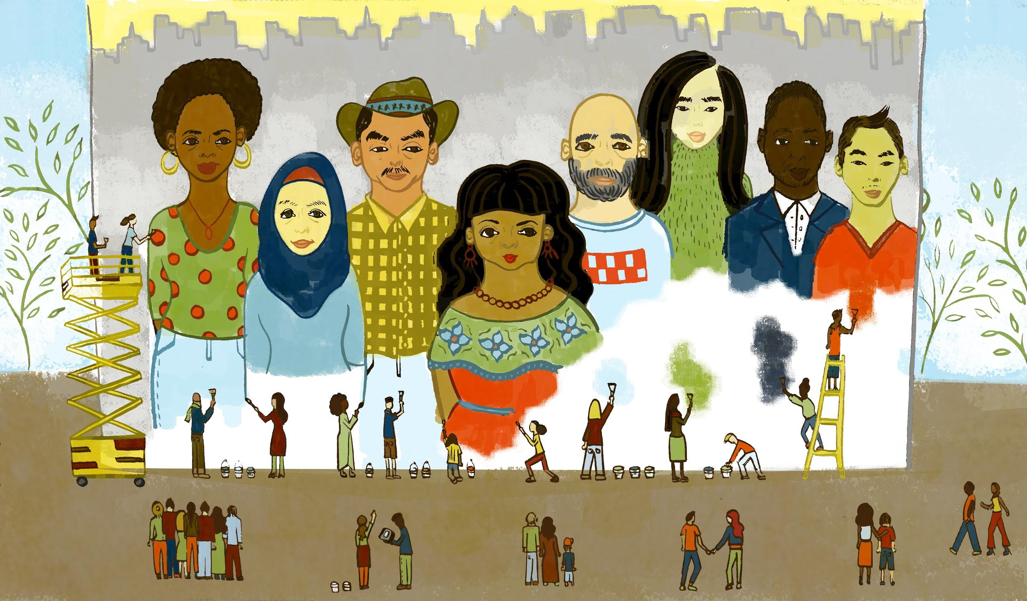
Joining together, New Yorkers uses creative tools, from paint to devices, in order to design, produce and share a mural of their community.

It is incredibly important that every New Yorker has the ability and opportunity to read, write, and participate online. Along with developing core 21C skills such as problem-solving and collaboration, web literacy, developed through this framework and support from the Institute for Media and Library Services (IMLS), helps people build and create content to make meaning through coding, composing, and remixing; to comprehend and navigate the web through evaluation, synthesis, and search skills; and to produce creative and secure online communities through principled conduct, among other things. Taken together, these essential elements of the digital era knowledge enable us be advocates for a healthy internet, and in turn, health societies.

The City of New York and community partners have invested in a number of programs that help New Yorkers – young and old – become healthier internet citizens. One significant undertaking is the Computer Science for All initiative (CS4All). Led by the NYC Department of Education, and part of Mayor de Blasio’s Equity and Excellence agenda, it has been tasked with an ambitious goal:

by 2025, train 5,000 K-12 teachers to bring CS education to the City’s 1.1 million public school students, with an emphasis on girls and students of color. With CS, students learn computational thinking, problem-solving, and collaboration to create with and better understand the technologies we interact with daily. CS4All provides teachers and school leaders with intensive professional development opportunities and high-quality curriculum. All training and resources are aligned to the CS4All Blueprint, an online academic and implementation guide for teaching CS in schools. Since the initiative launched in 2015, over 5,000 students have taken an AP Computer Science exam, 1,600 teachers trained, and 700 schools served.

The City also operates a large and wide-ranging network of public computer centers through its
libraries, community centers, and senior centers. Managed by the New York, Brooklyn, and
Queens Public Libraries, the Department of Parks and Recreation, the Department for the
Aging, Department of Youth and Community Development, and the NYC HousingAuthority, these 510 centers offer New Yorkers free access to computers and the internet – over 11,000 public workstations, and over 21,000 hours per week in open lab time. And they deliver a diverse array of digital tools and training programs. Skills training in these centers, offered at an average of over 2,800 hours per week across facilities, ranges from computer basics and introductions to email and search, to advanced topics like coding, robotics, and digital audio production. As part of this work, for example, the NYC Parks Department offers free media programs that range from filmmaking to game design.

Similarly, the Department for the Aging offers older New Yorkers free digital skills training in topics like civic engagement, financial literacy, and health management. The Mayor’s Office of the Chief Technology Officer works to coordinate this broad network of resources and programs, in particular supporting a subset of centers through its multi-agency NYC Connected Communities program.

This year, NYC also approved the future development of the Union Square Tech Training Center, which will offer digital skills training and be operated by Civic Hall. The Center will focus on training under-represented New Yorkers who don’t have access to the digital skills education needed to work in the tech industry.

On the community side, NYC boasts an impressive ecosystem of afterschool and informal learning organizations, many of which offer creative digital learning for young people. From the Staten Island MakerSpace, to the Museum of the Moving Image and New York Hall of Science in Queens to The Knowledge House in the Bronx, there is a core network of providers growing web literacy. Anchored in Hive NYC, a member-led peer learning network facilitated by representatives from organizations such as MOUSE, BeamCenter, and Dream Yard, over 60 non-profit organizations, such as museums, libraries, code clubs, advocacy groups, higher education institutions, and afterschool programs generate equitable and accessible education opportunities for thousands of young people to explore their digital interests through innovation, collaboration, discovery, and making.

Documenting the importance of networks for digital learning in NYC is this report from Hive Research Lab, which offers a toolkit for supporting young people developing skills beyond web literacy to the next step of life. Reflecting and celebrating the Hive network’s successes is Emoti-Con, NYC's biggest showcase for young designers, makers, technologists, and tinkerers who believe in digital literacies as a tool for positive change.

Web literacy helps the next generation get online as the builders, not just consumers, of the internet.

Meet Michael.
“we need to change who’s at the wheel”

Michael Preston is a managing partner of CSforALL, which makes high-quality computer science an integral part of learning for K-12 students and teachers, and promotes adoption of the computational thinking skills, so they are creators in the digital economy, not just consumers. With its origins as CSNYC, supporters of a dynamic NYC experiment, CSforALL now boasts over 500 member organizations nationally – from content providers to school districts to funders – connecting stakeholders, supporting new initiatives, and sharing progress with local and national audiences. CSforALL facilitates the emergence of thoughtful, active, and ethical citizens that our technology-driven world needs. A participatory, ground-up approach to computer science is key for learning and a more web literate population.

MF: Tell us about your work.
Michael: In 2013, while at the NYC Department of Education (DoE), I started working on a project to bring sequences of computer science (CS) courses to middle and high schools. Later I joined CSNYC, a non-profit organization with a mission of providing high-quality CS to every public student in NYC’s K-12 system. Early on, CSNYC demonstrated that teachers from any discipline can effectively teach CS; they didn’t need to be experts to provide meaningful learning experiences. The work quickly expanded and, in 2015, with the City’s equity and excellence initiatives, Mayor de Blasio announced the creation of CS4All, a 10-year initiative to reach all 1.1 million students in the city’s public schools. The launch of CS4All enabled us to transition our work to the NYC DoE as a public-private partnership. Thanks to leaders like Debbie Marcus, NYC embraced an ambitious goal of serving every student – truly “computer science for all” – at every level of schooling across K-12 bytraining 5,000 teachers in over 1,500 schools. The NYC DoE also created an online blueprint that defines K-12 computer science according to a set of commonly agreed upon concepts and practices. It’s available to other districts and states, demonstrating how a major city is does it.

The human side of CS is creative problem-solving, collaboration, and communication skills. It’s also why web literacy matters; it’s complementary to CS. Both focus on how things work, their implications for society, and the need for ethics, and both explore issues such as the impact of bias on data and the secure flow of information across networks. Be critical, be safe, be productive.

MF: What are you proud of?
Michael: New York City’s CS4All initiative grew out of a dynamic pairing of local knowledge and relationships. Working with common purpose enabled CS to rise to the national stage, and our role as facilitators of that collective progress. During the 2017-18 school year, nearly 135,000 students experienced hands-on, meaningful CS education across city schools – a 44% increase from the previous year. Nationally, over 40 states in the US have set a CS policy in motion, generating conditions for a more equitable pathway to college and career success.

All of this came together at our Detroit Summit: 500 people attended, with 270 commitments to bring 47 million learning opportunities to students and teachers in the coming year. We also announced a new advisory board and Accessibility Pledge focused on serving students with disabilities in computing education.

MF: What challenges persist to developing CS skills – locally and beyond?
Michael: There are two intertwined problems: equity and implementation. Regarding equity, the reality is that CS is not activating the talent it needs. Increasingly, the designers, architects, and builders of CS must reflect the lived experience of many, especially underrepresented communities. We must make sure kids have tools that help them address what they care about in their daily lives. The greater diversity of people who have CS skills, the more they can directly and accurately respond to issues that our communities face – violence, health problems, racial, gender, and other kinds of discrimination – rather than technology companies exclusively deciding what problems need to be solved. Also, we can do better to avoid really bad outcomes like biased facial recognition fiascos or ethical challenges of tech that disproportionately affect the vulnerable. One important step toward doing better is changing who’s at the wheel.

The other challenge is implementation, which is low across the country. There’s still a sense among leaders that CS is some sort of specialized knowledge, and that it’s too hard. That fear can inhibit school districts and cities from making good decisions for CS based on what they already know about their local contexts and student populations. Another hurdle is making the case for CS as worthy of a systemic change approach, when some see this as an unreplicable NYC initiative. So we work with districts around the country using generalizable tools and helping them get clarity on why a common vision for why CS matters. Getting districts on board and multiple stakeholders saying why CS matters to their community – jobs, civic engagement, joy, equity, education reform – helps create a way for districts and their communities to define a locally-owned approach. Without local ownership, we risk losing momentum, and even the CS movement altogether, if we accept really low-level implementation that just reinforces current inequalities.

MF: How can NYC be an active partner in this work?
Michael: CS4All has had some necessary conditions in place from the start: for example, a very engaged community, a high-functioning DoE, and ongoing internet and infrastructure upgrades to schools. All of these factors are significant. That said, investments have not always targeted maintaining the CS infrastructure. Most schools continue to have terrible bandwidth. Furthermore, the homework gap based on broadband access is real, especially for homeless and home-insecure students.

Final Word
Practically everything we use today is a computer – most modes of transportation, entertainment devices, and even kitchen appliances. People must decide for themselves how to participate in the

design and development of new technologies, and until we fix that, we will continue to suffer from a representation issue that continues to reproduce the conditions of inequality. When we get to year 10 of CS4All, will that be enough? How do we make sure this work becomes the new normal?

**Since this interview was conducted, Michael Preston has transitioned to a new position as Executive Director of the Joan Ganz Cooney Center at Sesame Workshop, a research and innovation lab that works to advance children's learning with media and technology.

Meet Davis.
“we need to know how our data is being used by entities of all shapes and sizes”

Davis Erin Anderson is the Program Manager for Technology, Culture & Libraries at the Metropolitan New York Library Council (METRO), a membership organization serving 250 institutions, reaching thousands of library staff members across NYC and Westchester County. A web literacy expert, Davis offers training and resources that advance critical skills for public library staff and patrons. She helps learners build capacity to “read, write, and participate” online through evaluating, creating, and protecting online information. Her leadership means more people understand how to safely access and use the web they want, not just the web they have.

MF: Tell us about your work.
Davis: I work to understand the impact of technology on culture at large, translating these challenges into real solutions for library staff. I foster partnerships with our library systems, as well as groups like Data & Society and Digital Equity Lab at The New School. I also conduct lots of trainings with Mozilla’s Core Curriculum for Web Literacy. I recently designed and facilitated workshops for members of NYC’s Partnership for AfterSchool Education, a network of informal practitioners. Our learners got really into a hands-on, design-your-own algorithm activity. They contributed real-life examples of what it means to have a web that broadcasts unique content for each individual based on data-profiling. They taught me just as much as I taught them!

MF: What are you proud of?
Davis: From email at work to social media on the subway to television at home, we are consistently providing tech companies with a wealth of data about our lives. It’s critical we stay focused on digital trends and what they mean for library patrons, especially underserved populations who are exposed to far more threat.

To mitigate these risks, I directed NYC Digital Safety: Privacy & Security, funded by the City of New York Mayor’s Office of the Chief Technology Officer. In collaboration with Brooklyn Public Library, New York Public Library, and Queens Library, I facilitated an effort to design and deploy online modules and in-person curriculum. These resources helped public library staff understand online privacy and security so that they can assist patrons. More than 1,100 library staff across the five boroughs participated in a NYC Digital Safety training. There is now at least one “privacy expert” at nearly all 215 branches across the city.

And we didn’t stop there! To celebrate, NYC’s three library systems and METRO launched the first Library Privacy Week. Together, libraries across the city hosted 30 events exploring ways people can protect their personally identifiable data online. We also worked with ten local artists and nine NYC library branches to host a multi-site art exhibit that interrogated what it means to sacrifice our personal information for the sake of convenience. Artwork can be found at Privacy in Public.

With a second-round of funding secured, we plan to design tools to help library staff move this information into the minds of the public.

MF: What challenges persist to developing web literacy skills – locally and beyond?
Davis: People who need web literacy skills most are also more unlikely to attend trainings due to pressing needs in their lives – they work multiple jobs, cannot afford childcare, or have appointments to keep in order to maintain their link to social services. We face challenges in closing the gap between what residents need to know and what library staff has been trained to share.

Libraries are, at heart, a natural antidote against these things: providing access to high quality, vetted information is in the library’s DNA. Protecting patron privacy is our cornerstone ethos. But as a society, we need a deeper conversation. We need to popularize and build on the work of researchers like Safiya Umoja Noble, studying algorithmic bias, machine-learning, and social justice regarding the information infrastructure.

MF: How can NYC be an active partner in this work?
Davis: The city is well-positioned to build coalitions that unite key players and help rally library systems to collectively mitigate the harm caused by a predatory data-gathering environment. But a better question is why put libraries in this position in the first place? Libraries have been – and will continue to be – a trusted voice for advancing “reading, writing, and participating” online safely and securely, in service to an informed public. We need a better approach to data protection, full stop. Without a coordinated response, these issues are left to the individual. The sheer realities around personal privacy on the internet can easily lead to disempowerment. We need effective approaches to keeping our data safe, real regulation in the technology space, and more accountability when it comes to data privacy.

Final Word
Education is a catalyst for change. The connection between web literacy and privacy is essential: we need to know how our data is being used by entities of all shapes and sizes. Awareness is a great first step, but we have to move into creating power for ourselves and our communities. Moving that power into collective action can send our governing bodies the message that we need clear rules in place to control how our data is being collected, retained, and used.

Participate/Now what?

The NYC Internet Health Report is a snapshot of what’s happening right now, through a digital rights and equity lens. We don’t have all the answers. If anything, we’re asking more of them. To make the internet healthier, we need people to understand, care – and then take action. We hope the report helps start conversations and invite you to copy, repurpose, embed, debate, download, and share it.

The internet will only become much healthier through structural changes, thoughtful governance, and better protection of everyone using digital products and services everywhere. Let’s keep demanding that these things happen, and collectively push for change. Get involved with Mozilla:
- Learn about Mozilla’s policy initiatives and campaigns
- Apply to be a Fellow
- Become a Mozilla Open Leader
- Join us at Mozfest or the Global Sprint
- Explore more opportunities to help keep the internet healthy

Acknowledgements

To all of our interviewees -- thank you for leading the City forward and sharing your inspiring stories with us! And gratitude to these NYC agencies and people for their generous participation:

- Mayor’s Office of the Chief Technology Officer: Samantha Grassle, Josh Breitbart, Kate Hohman, and Oscar Romero
- Mayor’s Office of Data Analytics: Kelly Jin
- Mayor’s Office of People with Disabilities: Walei Sabry
- NYC Commission on Human Rights: Brittny Saunders
- Department of Education: Debbie Marcus and David Pena
- Small Business Services: Lauren Andersen

Special thanks to the Mozilla Foundation for this unique opportunity, to the fellows team and Rizwan Tufail, and a huge, heartfelt thanks to Samantha Burton, Solana Larsen, Paul Zenke and Jairus Khan for championing this initiative throughout. Thanks to Kevin Zawacki and AnnMarie Carrothers for all around Moz support. Thanks to Greta Byrum, Ryan Gerety, Rafi Santos, Hillary Kolos, Brian Cohen, Bruce Lincoln, Dabria Alston, An-Me Chung, and all the beta readers who helped shape this effort. Thank you to Grace Lynne for beautiful illustrations and Leo Goldsmith for editorial polish. And of course, thanks to my family.

internethealth.nyc
internethealth@mozillafoundation.org
2019

